**Portable Prompter Setup**

1. Loosen the two thumb screws on base of Impact – Heavy Duty Tripod. This will allow you to expand the tripod legs.

1. After expanding tripod legs, tighten both base thumb screws. Ensure there is enough clearance at the base of the tripod to fit the sand bag.
2. Insert sand bag at bottom of tripod base. This will ensure the prompter will not fall due to inclement weather.

1. Loosen lower extendable center thumb and extend the height to about chin level.

1. Next Screw the double-ended spigot tightly into the bottom of the portable prompter.

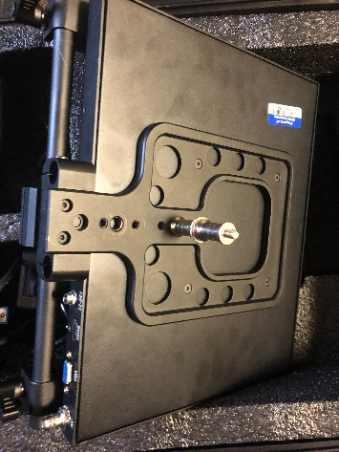

1. Loosen the top Thumb screw on the extendable center.

1. Attach portable prompter to the tripod and tighten the top thumb screw

1. Loosen thumb screw on the back of the Prompter to adjust the mirror.

1. Adjust mirror (top) at a 45 degree angle from the prompter screen (bottom) and then tighten the Thumb screws on the back of the prompter.

1. Next locate the magnetic prompter hood, Unfold and zip up both sides of the hood.

1. Place the magnetic hood onto the back of the mirror (top).

1. Connect the power supply (screw in to secure) and HDMI cable into the back of the prompter.   
   A picture containing indoor, machine, bicycle, bike

   Description automatically generatedA close up of a cable

   Description automatically generated with low confidence
2. If you are shooting inside and have access to a power outlet. Connect the power cable to outlet.

13a. If you do not have access to power. Connect prompter power to the Portable power supply in the Prompter kit.

1. Next Connect HDMI cable to your Laptop.

14a. If you do not have an HDMI port on your laptop. Use the USB-C to HDMI cable provided.

1. Locate Thumb mouse and plug usb dongle into your laptop.

1. Power on portable power supply if you are not connected to power outlet. Then Power on Prompter

1. Adjust Screen Resolution for Prompter to 1280 x 1024
   1. Right click on Desktop and select Display Settings

* 1. Press Identify to find the screen number for the portable prompter. Select Screen 2 (it should be highlighted blue)

* 1. Scroll down in your display setting to find “Display resolution”. Click the drop down arrow and select 1280 x 1024

* 1. When Prompted to keep display settings. Select “Keep Changes”

* 1. Exit out of display settings

1. Launch Prompter4 Program with Script (see KNPN How To’s – Prompter4 for more information)
2. Drag talent screen to Prompter screen and maximize window
3. Ensure there is a battery in the thumb mouse. Turn on and scroll up/down thru script.

Scroll

Power